Project Documentation

ISTE-330 Database Connectivity and Access

Alinity

Document (filename): ISTE-330_Project_Documentation_Alinity

Author(s): Lucija Filipović, Mislav Rukonić, Sven Slivar, Matej Petrić

Date (last change): 2021-03-18

Version (last version):

|  |  |  |  |
| --- | --- | --- | --- |
| *Version* | *Description of Change* | *Author(s)* | *Date* |
| 1.0 | Document Proposal Creation | All | 2021-03-18 |
| 1.1 | Document Proposal Fixes and M1 Content | All | 2021-03-24 |
| 1.2 | Document M2 Content | All | 2021-03-30 |
| 1.3 | Document M3 Content | All | 2021-04-10 |
| 1.4 | Document M4 Content | All | 2021-04-18 |

Table of contents

1 Introduction 3

1.1 Overview 3

1.2 Purpose and Scope 3

1.3 Background 3

1.4 References 3

1.5 Document Overview 3

2 Problem Description and Solution Architecture 4

2.1 Problem Description 4

2.2 Technologies and Architectural Design 4

2.3 Database Layer and Database Connectivity Layer 4

2.4 Business Layer 4

2.5 Presentation Layer 5

2.6 Areas of particular concern 5

3 Requirements 6

3.1 Context 6

3.2 Functional Requirements 6

3.3 Other (Non-Functional) Requirements 6

4 User Documentation 7

4.1 Graphical User Interface Design 7

4.2 User Manual 7

5 Installation, Configuration and Acceptance Testing 8

5.1 Installation 8

5.2 Configuration 8

5.3 Acceptance Testing 8

6 Final Remarks and Conclusion 9

# Introduction

This document will serve as an overview to the application and as documentation for any needs the user may have. Our project, “Alinity”, is a database of popular songs that the user wishes to keep track of, add new ones, and remove songs they do not like. Before the actual start of the project implementation, our team had to agree on the topic and the fact we all enjoy music determined it. Expected users are from different age groups and this fact will give our project a head start in future popularity. It is planned to be intuitive and simplistic. Some functionalities will be implemented such as searching for a particular song in the database or selecting some songs as favorite. The user will also be able to input song data into the database. The application architecture will consist of the data, business and presentational letter.

## Overview

“Alinity” will help users manage their songs; they can input song names alongside the artist, producer, album, etc. They will be able to input any amount of music, and delete music that they do not wish to store anymore. It will be like a very detailed playlist. The user can be as detailed as they want with their inputs, in the sense that we offer album names, producer names, record labels, etc. Our business domain/functionalities will function mainly on basic CRUD operations, being able to select, insert, update, and delete their favorite songs. Via these operations, our users will have a safe place to store their music, meaning that our project/application will make sure that each user has access to their music only. Some other functionalities that we wish to include are being able to open the selected song(s) in the users preferred music application or possibly even within our own application. With this, our application will provide a high level of security for our users. Each user will be able to create their own account with our log in/sign in feature, which will allow them to save their own music, playlists or songs just for themselves. This way the user can personalize their application while on the other hand we, as admins, will have the ability to access everything. Of course, we will attempt to prevent SQL injections via hashing.

## Purpose and Scope

The scope of this project’s clients is wide. It is probably the application's greatest advantage. Music apps are proven as popular amongst all group ages(excluding people under 5 and over 75) by numerous existing applications such as “Spotify”, “Deezer”, etc.   
The main purpose of our project is to provide the users the possibility to interact with the app as much as possible in order to create a companion relationship of the “Alinity'' with its user. The idea of easy and intuitive access to songs and quick addition and editing personal favorites is one example of our team’s guides. This application will enable the user to experience the world of music in another way. Our application will grant the user the magic of creating its own playlists, following desired artists and learning everything about the song, album or performer. All of that can be accessed by a simple sign in or log in of the user. All of this in detail will be explained through this document.

This document describes the early stage functionalities and architecture. This project document’s scope will contain the complete structural documentation and explained functionalities but will not have any source code presented.

## Background

Our team is dedicated to creating an application that tracks and stores all of your favorite songs. We have decided to create this application because we believe that everyone deserves absolutely the best when it comes to the music. Our team consists of young and enthusiastic students that just want to invent something that would help other teenagers and young adult people to enjoy their everyday lives with our app. We may be amatures when it comes to development in general, but we are eager to make it as good as possible. We’ve decided to name our application “Alinity” because we view that term as something joyful, which reminds us of the feeling that music presents us.

## References

We will be using the following:

* Java SE v. 15 ([Java SE Development Kit 15 - Downloads](https://www.oracle.com/java/technologies/javase-jdk15-downloads.html))
* IntelliJ IDEA Community Edition 2020.3.1 (<https://www.jetbrains.com/idea/download/#section=windows>)
* MySql Database 8.0.23. (<https://www.mysql.com/downloads/>)
* MySql Workbench 8.0.23. (<https://dev.mysql.com/downloads/workbench/>)
* Connector/J 8.0.23. (<https://dev.mysql.com/downloads/connector/j/>)
* Public API - Idea

Format of the final deliverable will be the source code handed directly to our professor. Due to time restrictions, we were unable to implement the final app as a jar file for general use. However, we believe that this will not impact the way the app works in terms of accessibility by our professor, nor will it affect our direct grade.

## Document Overview

The introduction section of this document describes the basics and essence of our application, and a base introduction as to how we plan to tackle and solve our problem. Included in the introduction are a list of the references that we will be used throughout the development of our application (subject to change) as well as an overview. purpose, and background to our ideas and how we plan to execute them. The problem description and solution architecture will go into more detail about what our application is attempting to provide to our users, and a way as which we will attempt to do so. All of our layers will follow basic layered architecture, but for the most part, we will mainly focus on the database and data layer to work perfectly. The requirements section will explain to the user how our application can be used and what a user needs in order for it to work as intended. User documentation will contain a short guide on how to launch the application, and a demonstration of someone using the application so that they know what to do once they are ready to store music. Installation will cover a detailed way in how the user can install the application and what the installer will offer. We are also giving access to all the references we have used in this project, we are trying to utilize most of the public APIs in order to provide users with the best possible experience. Users matter most to us, we are here to make the most pleasurable experience for our clients, there is no point in creating a project in which our clients can’t trust .The final thoughts and conclusions will cover our, the developers, thoughts about the application and what we think about our final product.

# Problem Description and Solution Architecture

## Problem Description

Our main goal would be accomplished by creating a main database that would probably use a public spotify or deezer API (an idea), we found free official API’s on github. Our goal would be achieved by connecting them together and then we would represent a user simple GUI where the user has a ‘Search box’ and he inputs the desired song name. After it pops out the list of possible search queries, the user could select the desired songs, then he would get a link that would play the song for him. Our second solution would be to create our own database without an API, and we would try to make a method that would extract the string of the string name and author and then it would automatically paste them into the search bar in deezer or spotify and link the user to the page, or even into youtube if we desire so. Before all of that the user will be able to log in using an account that has already been made, or creating an account if the user doesn’t have one. This way the user can save the music preference and the whole application will be more personalized rather than random, which will be better for the user. We will of course encrypt the password needed to log-in/sign-in.

## Technologies and Architectural Design

For the project we are going to use layered architecture, which will consist of a number of different layers that are defined with each layer performing a well-defined set of operations. Each layer will do some operations that become closer to machine instruction set progressively. We decided to do it this way because we think it suits our project the best and will help us achieve what we want. The layered architecture contains a user interaction layer which will have the menu so a user can find a way around the application, screens which will show the data and some kind of buttons so a person can interact with the application. The other layers are functionality layers which will show how the system behaves based on business rules, business rules layer that does business processes written as business rules, application core layer which is the main program and other components and database layer which will contain tables, indexes and search engine.

For programming languages, we will be using Java for a lot of our code. This is a language with which we are familiar with and know well. In terms of our database, MySQL seems to be the best choice for our entire team. We discussed possibly doing this with other languages, but Java suited us best.

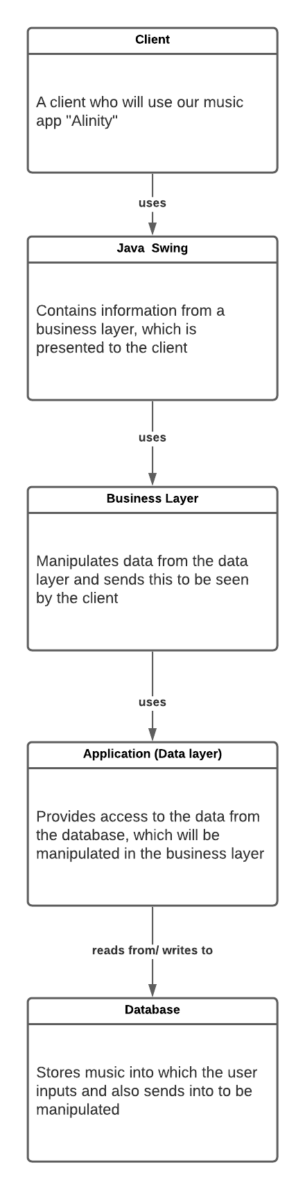

* The client will be presented with a GUI which will be created in java Swing. They will be able to login/sign-up, and then access information from the database using the different layers presented above.
* The “Java Swing” layer will be used as our presentation layer, which will be used to display the above information to the user. It will be able to show this to the user via the business layer.
* The business layer will communicate with the presentation and data layer. It will be able to manipulate information from the data layer to then fulfil the requests of the user to display in the presentation layer.
* The data layer is responsible for getting the information from the database and preparing that data to be manipulated in the business layer.
* Our database will be used to hold all information. It will communicate with the data layer to establish a connection to the database to be able to get and set data to be prepared for manipulation.

## Database Layer and Database Connectivity Layer

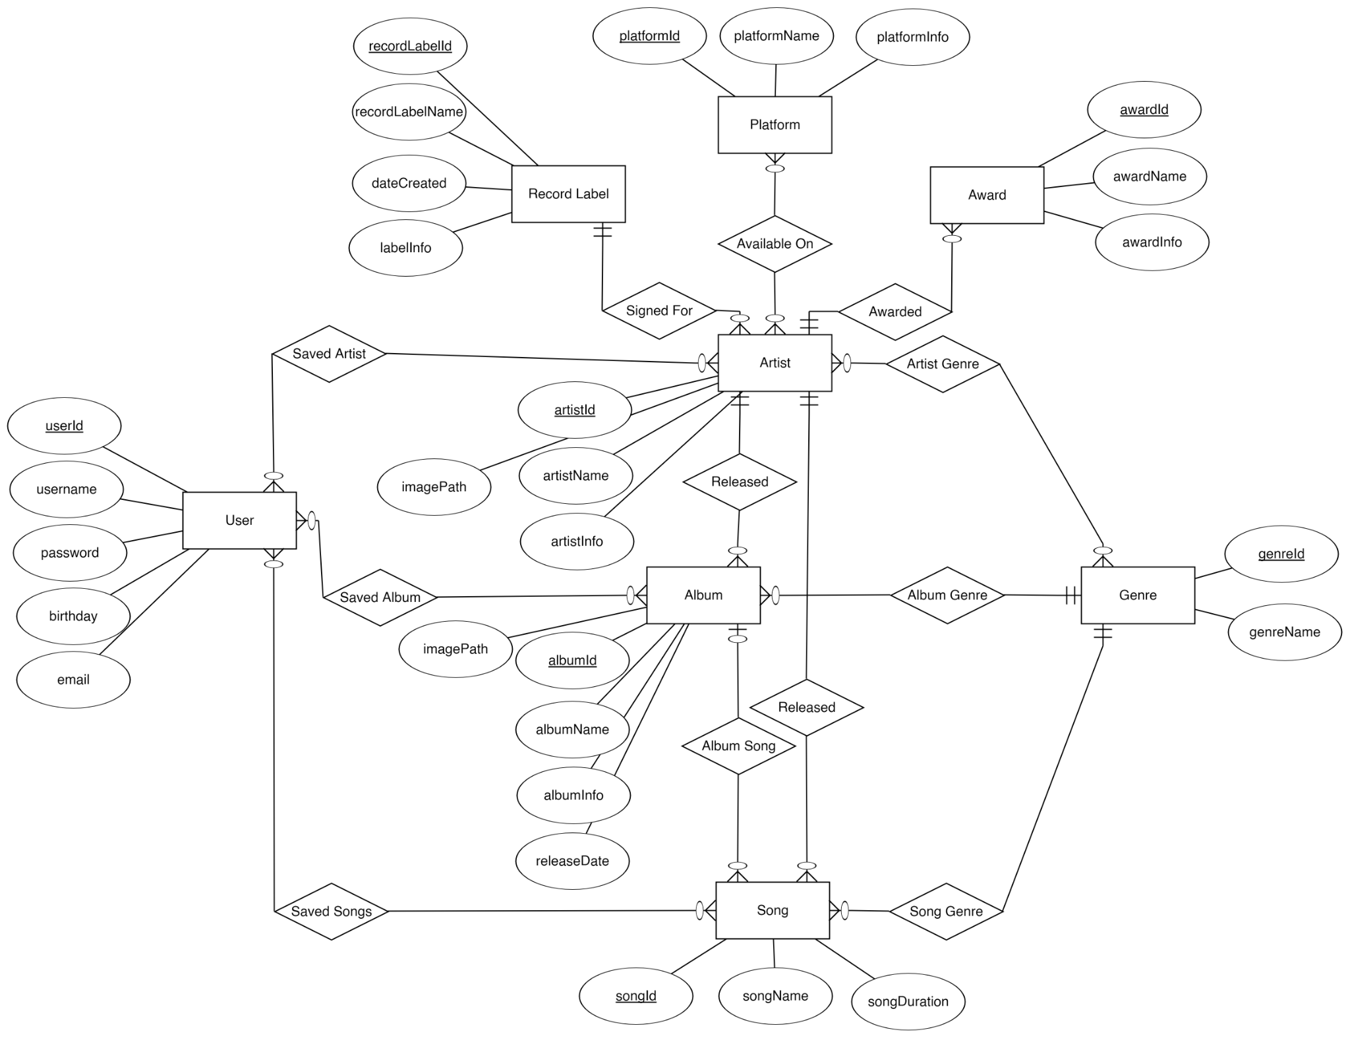

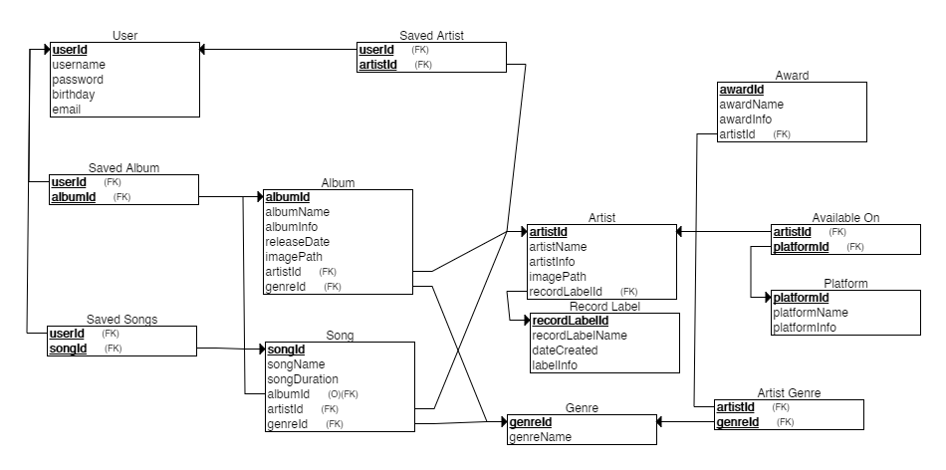

The first image is a representation of our database model in an Entity-Relationship diagram. It represents how a user's information will be stored, and with that information, access important information about their stored songs. Each song, album, and artist is directly in a relationship with the user, so the user has access to this information. Less important information that would need to be either requested or loaded initially for each of the above three mentioned entities are stored and have relationships with the three main entities in their respective orders. One of the more peculiar entities, the platform one, will be used to display to the user where they can listen to the selected music (YouTube, Spotify, etc).

The second image is a representation of how the database tables will look like once the database layer will be created. Each relation is represented with an arrow, with above relational diamonds being represented as different tables which contain our foreign keys.

To be thorough, the user table represents our user’s login information and credentials. With this, they will immediately have access to search through a table of songs, artists with the saved albums, song, and artists tables. These act as intermediaries where the user’s ID is held so that the database will know which user is connected, and then, display songs, albums, and artists which they have saved via the Song, Artist, and Album tables. Each artist has their own record label which they are signed to via the Record Label table. Genres are represented via their connection to the song table, with specific artist genres being presented in the Artist Genre table. Also, artists are displayed in the Available On/Platform tables, where an artists ID and platforms ID are taken to display where a user can listen to that artist when they click our “listen with” button. Awards are represented to display which artists have won what, as the artistID is a foreign key in the Award table.

**Database Dictionary**

|  |  |  |  |  |  |  |
| --- | --- | --- | --- | --- | --- | --- |
| **Table Name** | **Column Names** | **Data Types** | **Short Descriptions** | **Constraints** | **Restrictions** | **Sample Data** |
| User | userId, username, password, birthday,  email | int,  varchar,  varchar,  date,  varchar | userId: represents a user, with which they will have access to their own stored songs, albums, and artists  username: the username that will be used for login  password: the password for the user  birthday: a general storage for extra validation of a user (and to wish them a happy birthday)  email: verification and identification of a user | userId: auto_increment, primary key  username: not null  password: not null  birthday: not null  email: not null,  role: not null default ‘general’ | userId:  username: 50  password: 500  birthday:  email: 50  role: 20 | 1,  mjr8741,  password12,  1999-12-11,  [mjr8741@rit.edu](mailto:mjr8741@rit.edu),  Admin |
| Gerne | genreId,  genreName | int,  varchar | genreId: represents a genre of music by ID  genreName: a name of music genre | genreId: not null, auto_increment, primary key  genreName: not null | genreId:  genreName:50 | 1,  Rap |
|  |  |  |  |  |  |  |
| Record_Label | recordLabelId,  recordLabelName,  dateCreated,  labelInfo | int,  varchar,  date,  varchar, | recordLabelId: represents a record label by ID  recordLabelName: the name of the record label  dateCreated: when the label was created  labelInfo: information about the record label | recordLabelId: not null, auto_increment, primary key  recordLabelName: not null  dateCreated: not null  labelInfo: not null | recordLabelId:  recordLabelName: 50  dateCreated:  labelInfo: 400 | 1,  Def Jam Records,  1984-02-13,  Def Jam Records was established in the early to mid 80s by Rick Rubin in his dorm room at NYU. |
| Platform | platformId,  platformName,  platformInfo | int,  varchar,  varchar | platformId: represents a music platform by ID  platformName: the actual name of the said platform  platformInfo: information about the platform | platformId: not null, auto_increment, primary key  platformName: not null  platformInfo: not null | platformId:  platformName: 50  platformInfo: 400 | 1,  Spotify,  Spotify is the leading brand in music streaming around the world. |
| Artist | artistId,  artistName,  artistInfo,  imagePath,  recordLabelId | int,  varchar,  varchar,  varchar,  int | artistId: represents an artist via ID  artistName: the name of a music artist  artistInfo: information about the artist  imagePath: holds the path to the image  recordLabelID: represents a record label by ID | artistID: not null, auto_increment, primary key  artistName: not null,  artistInfo: not null  imagePath: not null  recordLabelId: not null, foreign key | artistID:  artistName: 50  artistInfo: 400  imagePath: 50  recordLabelId: | 1,  Snoop Dogg,  Calvin Cordozar Broadus Jr. is an American rapper and producer. He got his rap name because his mom used to call him Snoopy when he was little.,  images\\snoopDogg.jpg,  3 |
| Album | albumId,  albumName,  albumInfo,  releaseDate,  imagePath  artistId,  genreId | int,  varchar,  varchar,  date,  varchar,  int,  int | albumId: represents an album by ID  albumName: the name of a music album  albumInfo: information about a music album  releaseDate: the day the album was released  imagePath: holds the path to an image  artistId: represents an artist by ID  genreId: represents a genre by ID | albumId: not null, auto_increment, primary key  albumName:not null  albumInfo: not null  releaseDate: not null  imagePath: not null  artistId: not null, foreign key  genreId: not null, foreign key | albumId:  albumName: 50  albumInfo: 200  releaseDate:  imagePath: 50  artistId:  genreId: | 1,  The Chronic.,  The Chronic was Dr. Dre’s debut studio album. Many young rappers grew up on his music.,  1992-12-15,  images\\theChronic.jpg |
| Award | awardId,  awardName,  awardInfo,  artistId | int,  varchar,  varchar,  int | awardId: represents an award by ID  awardName: the name of an award  awardInfo: information about an award  artistId: represents an artist by name | awardId: not null, auto_increment, primary key  awardName: not null  awardInfo: not null  artistId: not null, foreign key | awardId:  awardName: 50  awardInfo: 400  artistId: | 1,  Best Rap Single.,  This award resembles the most inspiring and innovative rap single of the year.,  7 |
| Saved_Artist | userId,  artistId | int,  int | userId: represents a user by ID  artistId: represents a music artist by ID | userId: not null, primary key, foreign key  artistId: not null, primary key, foreign key | userId:  artistId: | 3,  6 |
| Saved_Album | userId,  albumId | int,  int | userId: represents a user by ID  albumID: represents an album by ID | userId: not null, primary key, foreign key  albumId: not null, primary key, foreign key | userId:  albumId: | 18,  12 |
| Artist_Genre | artistId,  genreId | int,  int | artistId: represents an artist by ID  genreID: represents a genre by ID | artistId: not null, primary key, foreign key  genreId: not null, primary key, foreign key | artistId:  genreId: | 123,  21 |
| Available_On | artistId,  platformId | int,  int | artistId:  represents an artist by ID  platformID: represents a platform by ID | artistId: not null, primary key, foreign key  platformID: not null, primary key, foreign key | artistId:  platformId: | 223,  3 |
| Song | songId,  songName,  songDuration,  albumId,  artistId,  genreId | int,  varchar,  int,  int,  int,  int | songId: represents a song by ID  songName: the name of a song  songDuration: duration of a song in seconds  albumId: represents an album by ID  artistId: represents an artist by ID  genreId: represents a genre by ID | songId: not null, auto_increment, primary key  songName: not null  songDuration: not null  albumId: foreign key  artistId: not null, foreign key  genreId: not null, foreign key | songId:  songName: 50  songDuration:  albumId:  artistId:  genreId: | 22,  Kickstart My Heart,  307,  2,  88,  9 |
| Saved_Songs | userId,  songId | int,  int | userId: represents a user by ID  songId: represents a song by ID | userId: not null, primary key, foreign key  songId: not null, primary key, foreign key | userID:  songID: | 9,  12 |

## Business Layer

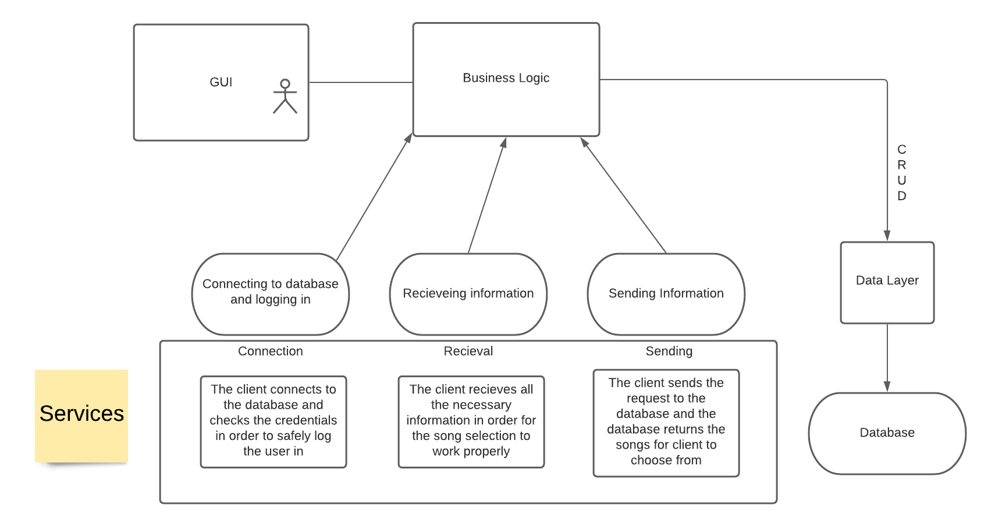

The business model of our application will have most tasks. It will manage all other layers. All of the CRUD operations will be done in the business layer on the data layer. After the data manipulation, the business layer will dynamically change the content of the view. The given image above shows how the business layer holds and deals with the operations to which it is connected. The “Song selection” and “Insertion of new song” are categorized as the CRUD operations(services), and give an example with a simple explanation of what it does. The business layer will have access to all other class attributes and their values. It will have the biggest ability to manipulate between the classes. So far we have connected to the database and the tables inside it to see if our code works to be able to communicate with our presentation layer, all of which is done in main. For each class we have implemented CRUD operations and printing the data from the classes. These CRUD operations will be limited, based on our new login system. The login system will authenticate the user’s username and password, and if it exists inside of the database, it will allow the user to login and use functions of our app. If the user fails 3 times, the app will exit. Another feature which will be implemented is the sign-up feature, which will insert new information for a new user, and then ask them to log in to validate said information.

As per our newest model, the business layer is performed and achieved via a new class, the AlinityController class. Here, all events and communication between the information in the data layer and how it’s displayed in the presentation layer is done. We were not able to figure out a way to present all information in the business layer to the presentation layer, so some calls to the presentation layer are made from the data layer. However, this does not affect the final output of how the application works, nor can the user directly interact with information from the data layer; this is done from the business layer. It’s just that something on the presentation side is updated within the data layer.

## Presentation Layer

The presentation layer of our music app is going to interact with users through a GUI. Its purpose is to display data given to it by the business model and to take user input which is then sent to the business model in order for the CRUD operations to take place. Our GUI design will be minimalistic so that users of any age can easily find a way around the application. The first window the user will see is a log-in or sign-in screen. After the user is logged in, there will be a simple menu with all the features of our application “Alinity”. The majority of the window will show users music or if the user just created an account random music/artists will be displayed. The purpose of this layer, and GUI is to make our application easy to use and to display our features in a modern way. The presentation layer is all about displaying and handling the user interface which will be connected to the business layer. The business layer will contain all the business logic and rules needed for our application and database to work. To be more exact it will be responsible for executing specific business rules that are associated with the request the user made. It determines creates/stores and changes so when the users interact with the presentation layer all the requests will go to the business layer.

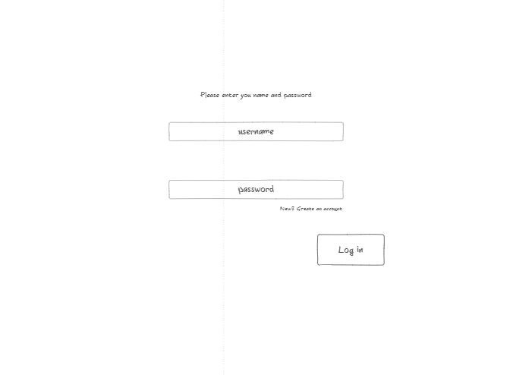

This is a starting page in our application without any design currently. It will be a simple log in or sign in page.

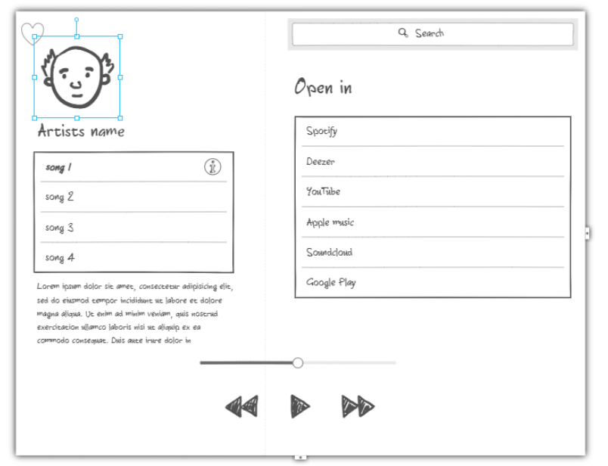

This is how the prototype of our application will look like. On the left side of the screen there will be the artists picture, name, songs and description. By clicking on the heart on the left side of the picture the user will “favorite” the artist and will follow its music and albums. Below the picture there will be a list of songs from that artist by clicking on a song the person can then open the song in another platform (Spotify, Deezer, YouTube and other). On the right upper corner there will be a search label that will enable users to search for their favorite artists, albums or songs.

In terms of the presentation layer communicating with the business layer, when the connection to the database is established. the GUI will present to the user an option to either sign up and login. Each option will either try to authenticate or create a new user and then lead to the functionality of our app. Each option that the user can use is connected with the user and their user ID. Their ID is a number in the database which they do not see, and with this number, each user will be able to select songs from our database and possibly even insert new ones that they like to listen to and such.

After a while we added a few new windows that will be shown in the pictures below.

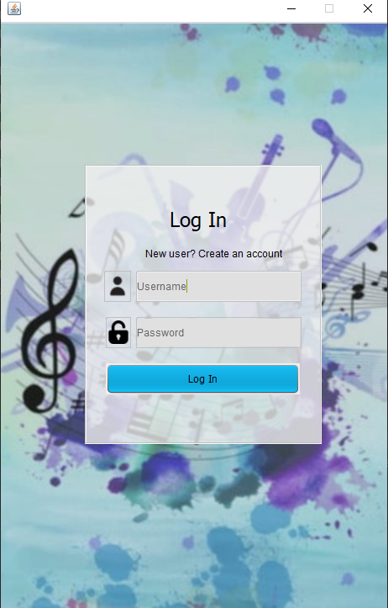

This is the first window the user will see where the user can enter username and password to login, if the user does not have an account the user can click on “new user? Create an account” to open a new window and create a new account. In that case the window from the picture below will be opened.

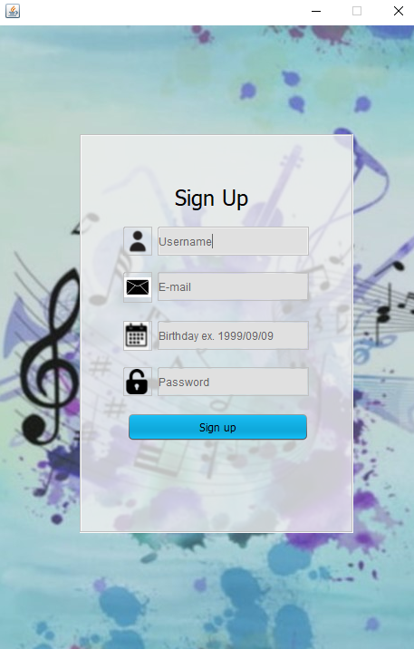

This is the window user will see when creating a new account. To create a new account user needs to input all of the following data: username, e-mail, birthday and password and then just click sign up. After signing up the user will be directed to the next window which is also shown after the login window.

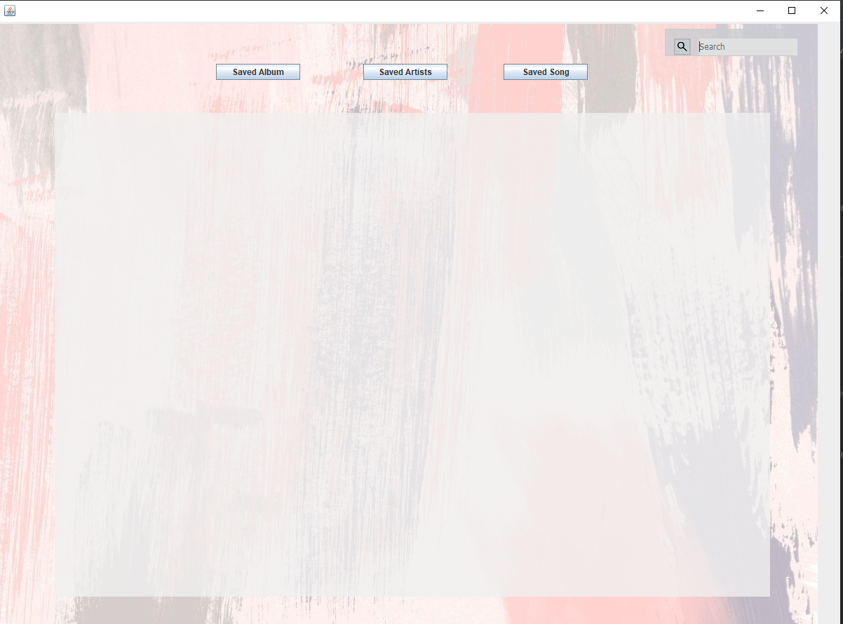

This is the next window that will be shown after the user logins or sign ups. In this window the user has a search bar where the user can search for artists, albums or songs. After the user inputs and presses enter the searched song/artist or album will be shown over the grey area on the screen, example shown in next picture.

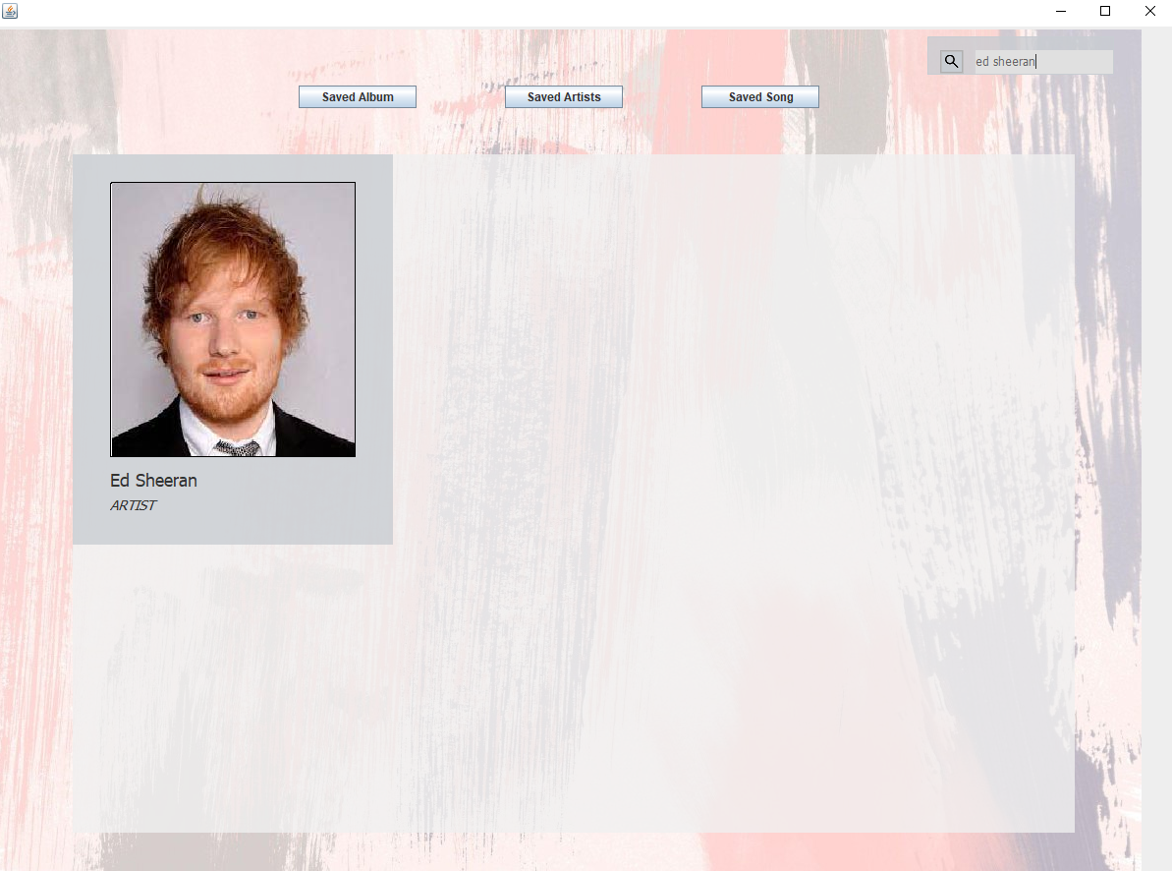

Next part of the gui are buttons: saved song/saved artist and saved album for which when the user clicks on will open a new window where it’s going to print out what the user saved. Another functionality that has been added is that when the user clicks on the picture of the artist the user will be asked if she/he wants to save that album/song/artist or not, and when the user clicks on the name of the son/artist/album the application will show where it’s available.

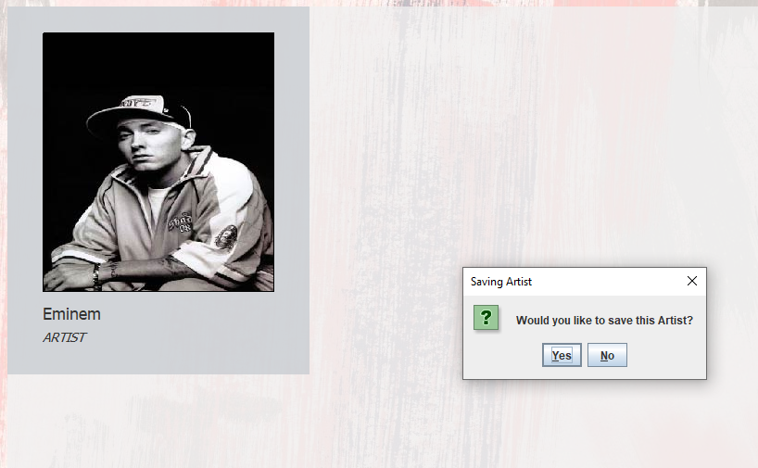

## Areas of particular concern

*[In this chapter, you should provide identification of areas of particular note or concerns. It could be about prerequisites (which must be respected) and assumptions, as well as possible risks for your project. Those could be related to an organization, planning, resources, technologies, and availability, as well as team members. You can describe a plan on how to mitigate those risks. You should start doing it for* ***deliverables and milestones #1 to #3*** *and finish it no later than* ***deliverable and milestone #4****.]*

Our current main concern is how will a user be able to access only their specific information of songs on login. Will every user, when they first sign up, have their own personal database created to store music with only user privileges? For example, on Facebook, you only see your friends, your posts, etc. You don’t see information about anyone else, or better said, you don’t have direct access to anyone else’s profile for editing. How will we make sure that our users will only have access to their “Facebook page” for their music? Is this something advanced for this project? This is a feature which we will look to implement after testing the application as admins, where we will all have access to only one main database. We will try to resolve this problem by thinking about it a lot and trying out things to figure it out. Other than that we might have problems with organization since we are all students with different schedules and busy lives and a lot of other projects. This problem could be easily resolved with setting up a meeting once or twice a week at the same time until the project is done at a time when all of us are available. By doing this we are determined to meet and will not be able to cancel the appointment since it will be a time when all of us are available. This is also connected to the planning, so if we are not organized there is no planning, and without planning there is no organization therefore, we will try to have our meetings once or twice a week at the same time and keep each other informed in our WhatsApp group.

Another concern that has showed up whilst designing our data layer in Java is how many select statements will we need to have for our database? Of course, we will not only support selecting everything, but we need to find some limit as to how and what we can let a user select information from the database. Also, since we have some intermediary tables which act as foreign key holders to connect our users with their own music (get albums where the user ID is equal to the current logged in user), we are a bit concerned as to how a user will be able to access their information. We assume that getters and setters will be put in place to allow access for that specific user in the Java class where albums, songs, and artists for a specific user are stored.

During working we have come to another concern which is how will we dynamically create jPanels, GUI to suit our needs. Because we need to create new jPanels/jLabels etc. for each song to display, for each artist and album. We are currently thinking about doing it in some kind of loop but since we didn’t do it ever we are not sure but will try.

# Requirements

## Context

In our application there will be features that connect the user to other environments, like for example “Spotify”, “Deezer”, “Youtube”, “Apple Music” and other similar applications. With this feature a user can very easily listen and access the discovered music. To be able to do this we will connect these platforms with the user by simply clicking on a button which will be linked to the platforms page. This relation is necessary for our application to work the way we want it to.

Unfortunately we were not able to connect this feature to the GUI, but it is fully implemented and functions as expected.

## Functional Requirements

Our current requirements are the 4 layers listed, which will be explained more in detail while we progress with this project. For now the details are generic but will be changed later on.

|  |  |
| --- | --- |
| Functionality 1 - Database | Create a database and allow it to be filled with information (specific user ID with their own DB of info might be implemented later). For now we are assuming that every user has the Workbench installed and therefore will be able to run our program with the database. |
| Functionality 2 - Data Layer | Data layer will assist in retrieving information from the database and will prepare that information for manipulation. Each table in the database will be its own class containing getter and setter methods together with the basic crud operation methods. |
| Functionality 3 - Business Layer | This layer will be the one the user “interacts with”. Whatever the user sees and does on the UI presentation layer, this layer will be the one representing the data displayed and stored. It will also be a bridge between the presentation layer and the data layer. All the logic is placed and done in this layer. |
| Functionality 4 - Presentation Layer | The UI that the user will see and will interact with. It will be created using the Java Swing framework. The design is to be simplistic and practical for a lightweight user interaction. |
| Functionality 5 - Data Selection | In the GUI user will have an option to use a search query. Inside a label user can type a desired artist or a song, and a search will be committed, if there is no match in the database, the user will be informed after the search is completed. |
| Functionality 6 - Data Insertion | In the GUI user will have an option to insert his own song/artist using a query. Inside a label user can type a desired input having all the needed parameters, and data will be stored to the database. |
| Functionality 7 - Showing database tables | In the GUI user will have an option to look at all of the songs and artists that are stored within the database. |
| Functionality 8 - User credentials | Each and every user can log in with their username and password and create a personal account so they can select their favorite songs/authors and receive suggestions similar to their likings. |
| Functionality 9 - Song selection | Users can select to play selected songs by choosing a platform to play on (example: Spotify, AppleMusic etc.) |
| Functionality 10 - Description | The user will be able to choose an artist and be able to view the artists current available songs/about/picture ordered in a hierarchical manner having the new songs displayed at the beginning. |
| Functionality 11 - Sharing on different platforms | Users will be able to share their song of choice by sending it to another person through email or some other kind of platform quickly. |
| Functionality 12 - Setting preferences and receiving data relevant to those preferences | Users will be able to like an artist or a song and based on what they liked the user will be able so see songs with the same genre of music they liked, this will help users to customize the application to their liking and have more |

## Other (Non-Functional) Requirements

Requirements for this software application will not be a burden on any users PC as it will be designed in a simple fashion. Users will only need to have basic knowledge of how to launch a desktop application, since we plan to export our final project as a jar file which does not require anyone to have Java or anything similar installed on their computers. The one thing that we are not sure about is how, with this approach, will people be able to connect to a database if it is not directly loaded/connected on their PC. Perhaps something like this should be hosted virtually somewhere so that anyone can have access to it. Aside from this, we will be delivering all source and compiled files so that our main client can test it as they please. One thing that we will need to have access to is, if we end up implementing the “Listen to on ‘music source’” feature, we will need to have access to the user’s primary browser to open that song in the browser of the chosen music application. Security will be implemented in a way similar to what was mentioned in previous parts of this document; admins will test this application first to check functionality locally, and only when we have successful results locally will we be able to begin the process of adapting this for multiple users, creating and checking privileges, etc. With having a server hosting the database, we would be able to have multiple users connected concurrently due to the focus on simplicity and optimization. Every error that occurs during the usage of the application, the basic users are informed that there is something wrong and they will be informed that in order to solve the issue, contacting an admin is required.

# 4 User Documentation

## 4.1. Graphical User Interface Design

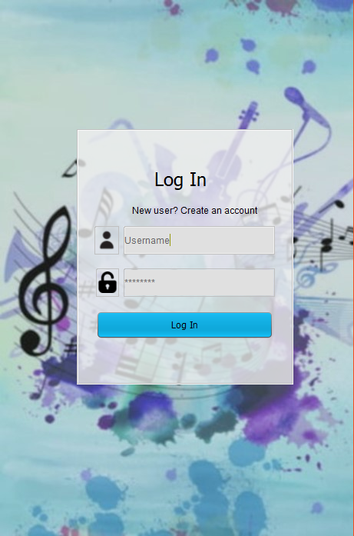

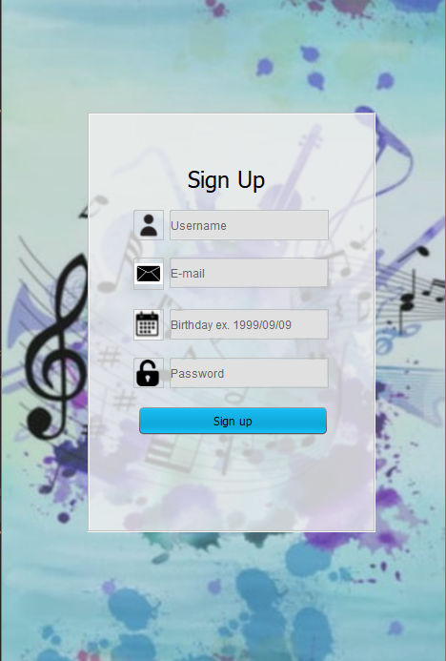

This will be the first screen the user sees. The design here is pretty simple since this is just a prototype and we will probably change it later on. On the middle of the upper screen we printed out our application name and we have functions here so that users can log in (or sign in) with a username and password. The user will need to create an account to be able to use our application. The whole design here is pretty simple so that users can easily find their way around. When the user clicks on login button next window will pop up.

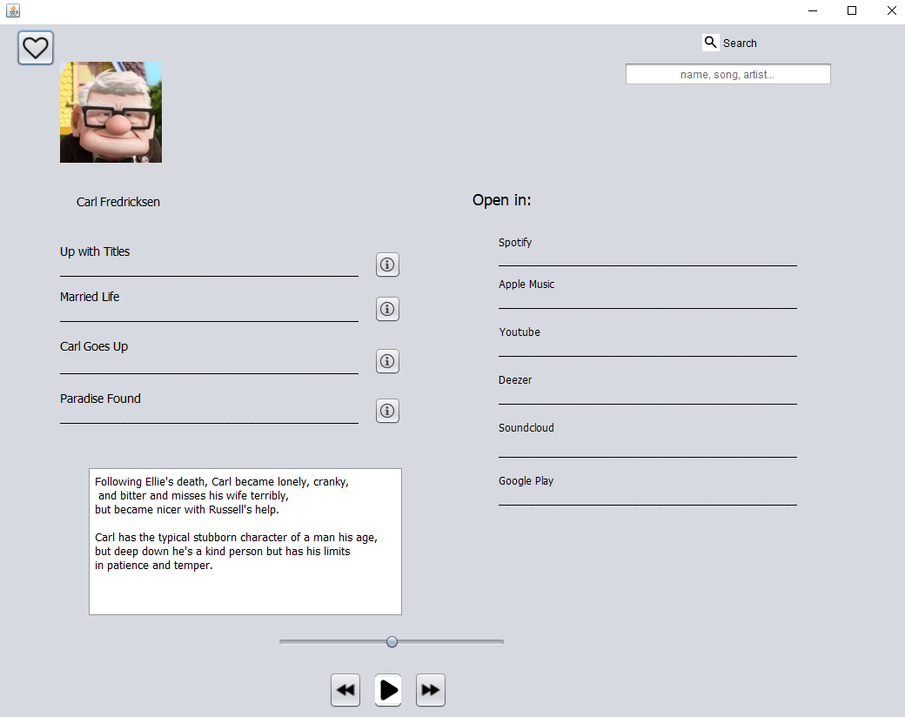

This is the second window where users can fully use our application. This window pop ups after the login button pressed. Design of this window is also pretty simple since it is also a prototype just to visually see what we need and the whole layout. The layout and design is pretty much the same as the sketch we have done. We plan on upgrading it a little bit later on. So far we have implemented the “liking” button, the play/next/prev buttons, info buttons and search bar, but so far the functions of those aren’t implemented. That will be our next step.

Our next concentration for this step to improve the design and work on user experience.

So far we have changed our graphical user interface a bit. In the pictures below we will show what has been changed.



This is the first window that will pop up when the user opens our application. Here the user can log in with credentials (username, password) or click on create new account to create an account. In that case the next picture window will pop up.



This is the next window that will pop up, where the user needs to enter data into all of the fields (username, email, birthday and password) to create an account. These two windows are just examples of our new graphical user interface that is more user friendly and more designed than the ones before. These are the improved versions and are more fun and easier to use.

For the main GUI we have changed it to look like the next picture.

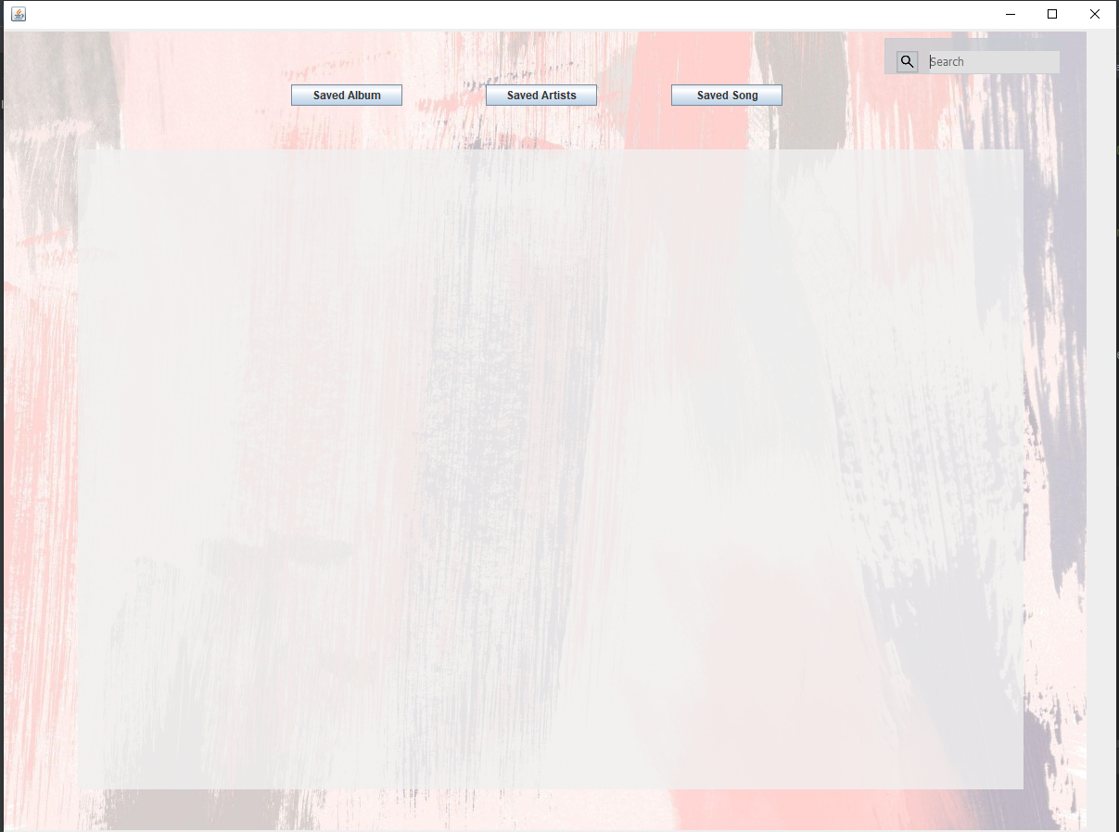

It’s pretty simple overall and easy to use. We have changed it so it can go nicely with the functionalities we have.

## 4.2. User Manual

The “Alinity” app opening:

* The user can open a source code in an IDE where he/she can add the stated driver, select the mentioned version of Java, create locally the provided database, and finally run the main class (AlinityMain) directly from his/her IDE.
* run the sql file in your Workbench
* run AlinityMain
* When the user runs the application he/she will be prompted to give information about the connection, database for which the user wants the connection
* connect
* create a new account by clicking on a new user?
* enter credentials (Your name, birthday, email and password)
* sign up
* use application:

After the user has connected, he/she has numerous options of manipulating the database through the GUI. When a user runs our files there will be a pop up window that shows our application. The first window the user sees will be to enter the username and password. If the user doesn’t have an account made he/she can create it by clicking on the create an account. In this case the user will be able to create an account by entering username, e-mail, birthday and password. All of the fields are necessary to create an account. After the account has been created or the user is logged in the user can use our applications features. Firstly the user can search an album, song or artist by filling the field in the windows that has been shown after the log in( search in SearchGUI). When the user searches, the user can add the song/artist/album by using our “liking” feature which is accessed by clicking on the picture. Our liking feature enables the user to save that same song/album or artist. And the most important feature is that by clicking on the name of the album/song/artist the user can open see where it’s available on.

# 

# 5 Installation, Configuration and Acceptance Testing

## 5.1. Installation

1. Download an IDE such as IntelliJ (link: [Download IntelliJ IDEA: The Capable & Ergonomic Java IDE by JetBrains](https://www.jetbrains.com/idea/download/#section=windows))
2. Download the MySQL database (link: [MySQL Downloads](https://www.mysql.com/downloads/))
3. Download the MySQL Workbench (link: ([MySQL :: Download MySQL Workbench](https://dev.mysql.com/downloads/workbench/))
4. Download the Connector/J (link:[MySQL :: Download Connector/J](https://dev.mysql.com/downloads/connector/j/))

## 5.2. Configuration

1. Open the project folder in the installed IDE.
2. Link the downloaded driver to the libraries in the project structure.
3. Create the Alinity database locally
4. Select the adequate Java version (15) for running the project
5. Run the Main java class

## 5.3. Acceptance Testing

We have let a couple of our friends and colleagues test the application. They seemed to use our application with ease. They figured out how to find some of the songs and how to create a new account. They could also like their favorite songs and review their favorite selections.

# 6 Final Remarks and Conclusion

Our experience so far regarding working in teams and on this project has been great. We have had a little problem where one of the team members wasn’t working and left the team, but we managed to work through it and continue to be a great team. We are proud of the work we have done so far and how we did it, meaning doing it together as a team. Our positive experience is that we yet haven’t had a big code problem where we couldn’t find the solution fast. We are also very happy that we managed to find the time so that the 4 of us could work at the same time together. Our concerns are currently with how many select statements we will need to have for our database and with how the user will be able to access their information because we are concerned about the idea that each user will have to create their own database.

At the end of the project we are overall happy we did the functionalities that we have and the way we did it, but we are pretty unsatisfied with the way our working with gui has turned out. We underestimated how easy it is to connect the gui to the functionalities so we had some pretty big problems at the end of the project. We managed to fix most of them, but the look of the gui and the functionalities didn't turn out exactly how we wanted them to (design wise). And overall we are happy with our team because everyone was hardworking and wanted to learn. We didn’t have any problems with scheduling meetings or similar.

Deliverables: We will deliver a file with all of our source code and images as a Intellij project that can easily be run but running the project (AlinityMain.java)